**A Single Package Implementation of Various Groundwater/ Surface Water Interaction Algorithms with Examples**

**[mg: “stream depletion” in title?]**

**Conflict of interest:** None.

**Key words:**

**Article Impact Statement:** An open-source Python package GSWAPY is developed to provide a single package for various groundwater/ surface water interaction algorithms.

**Abstract**

Groundwater/surface water interaction algorithms have been developed, utilised, and modified by the authors and others for more than 10 years. They have been implemented in various codes for a range of research projects. This method note presents GSWAPY, an open-source Python package which incorporates n algorithms in a single Python package. These algorithms are: blah, blah & blah and represent a useful set of tools for incorporation into groundwater/surface water models. GSWAPY also contains an example Jupyter Notebook for each of the algorithm which works through a simple problem. The notebook problems can be modified for other problems of the underlying Python methods can be called with several lines of Python code. The source codes for GSWAPY are publicly available at GitHub (github link will go here)

**Introduction**

For the purposes of this paper we will define streamflow depletion as the portion of water taken from the river by an adjacent well (Glover & Balmer (1954)). Streamflow depletion caused by pumping can have serious impacts on downstream users (citation) and river health (citation) and so calculating streamflow depletion can be an important part of river management.

Modelling approaches for calculating streamflow depletion are generally fit for purpose, river modelling tools for water allocation and whole of catchment modelling may either ignore streamflow depletion (IQQM?) or implement a simple loss function (AWRA-L?) whereas groundwater modelling tools may use a three dimensional numerical modelling solution (MODFLOW). This paper will focus on analytical solutions for stream depletion.

List the solutions, find examples of coding, note that we provide a complete python package which incorporates all solutions in an easy to use package.

Solutions are discussed and then coding is discussed.

The analytical solutions described in this paper are discussed Further the depletion is influenced by omputed in terms of the distance of the well from the river; the properties of the aquifer, and time.

Different types of approach (ignore, loss, model, …, )

(?different modelling approaches? references)

**Algorithms in detail**

**GSWAPY**

**SDPY**

**[mg: alternative name? STREAMDEPY?]**

**Implementation**

Notes:

For each – paragraph on assumptions

[check the words in the rassam single-author paper]

Introduce concept of non-dimensional analysis

[add text on well pumping impacting on streams through stream depletion]

[knight et al 2005 text:

An integral solution for the effect of well pumping on stream flow depletion was initially published by Theis (1941). Glover and Balmer (1954) provided a solution in the form of a complementary error function. Other authors have also examined the effects of additional complexity, such as partially penetrating streams (Hunt, 1999), streambed clogging (Hantush 1965), semiconfined aquifer (Hunt 2003), no flow boundary (Knight et al. 2005), and multiple rivers (Hantush 1967).

Case 1: Depletion in semi-infinite aquifer with fully penetrating stream (Glover and Balmer, 1954)

The simplest case described here is for a semi-infinite aquifer with a fully penetrating stream (Glover and Balmer 1954).

The case assumes uniform aquifer transmissivity with a horizontal base, and the river at *x=0* is the only boundary. Changes in groundwater are assumed to be small relative to the overall aquifer storage. Pumping of groundwater at particular places and times are considered as input, with the only output being the depletion of water from the river.

Pumping is considered to start at time zero and to continue at a constant rate, at a point some distance (*x=a*) from the river (at *x=0*) (Fig. x1). The total flux of stream depletion into the groundwater from the river as a result of a continuous unit change at a point *x=a* can be given by:

*f3(a,t) = -*erfc*[ a / [2(Dt)½]*] Eq x1

where *f3* is the instantaneous flux of water from the river at time (*t*) as a result of a continuous unit pumping sink applied at a point with distance *x=a* from the river, and aquifer properties given by diffusivity *D=K hbar/phi*; where *K* is the saturated hydraulic conductivity, *hbar* is the average height of water table, and *phi* is the drainable porosity (Fig. x). The function erfc is the complementary error function (given in Section 7.1.2 of Abramowitz and Stegun (1965)). By multiplying the value *f3* in Eq. (x1) by the pumping rate due to a continuous point sink, the actual flux from the river can be calculated.

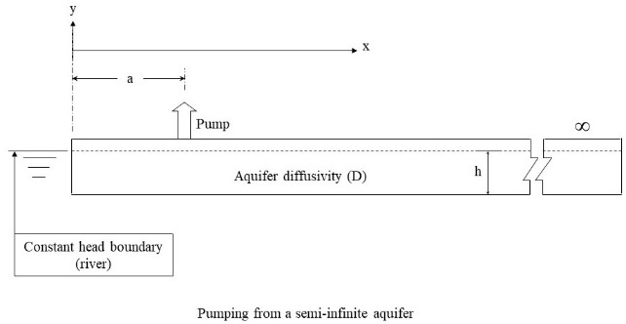

***Fig x1:*** *Uniform aquifer with horizontal base, diffusivity (D), saturated thickness (h). Fully penetrating river at x=0, and a pump at distance x=a from the river.*

Stream depletion due to pumping increases with time, depending on the distance of the pump from the river and the aquifer diffusivity (D). Fig x2 shows the variation in stream depletion factor as D is varied. As D increases, the response time reduces, and the stream depletion occurs earlier.

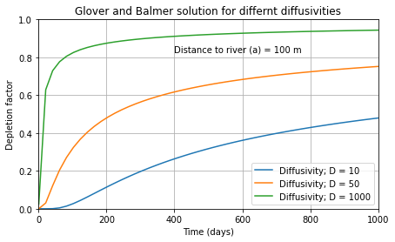

**Fig x2:** *Stream depletion (expressed as a proportion of pumping rate) for 3 different aquifer diffusivities.*

Case 2: Depletion with semi-pervious layer (Hantush, 1965)

This case incorporates the impact of a thin stream bed layer, which is less permeable than the aquifer. Hantush (1965) proposed a solution where the impact of a semi-pervious stream bed was accounted for with the addition of a narrow layer between the aquifer and the river of conductivity *K’* and width *b’*, expressed as a retardation coefficient (*alpha*).

Alpha= k_aquifer / K_bank * bank_width

Z1 = a / np.sqrt(4 * D * t)

Z2 = a / Alpha + D * t / (Alpha ** 2)

Z3 = Z1 + (np.sqrt(D * t)) / Alpha

resp = exf(0, Z1) - exf(Z2, Z3)

where *resp* is the instantaneous flux of water from the river at time (*t*) as a result of a continuous unit pumping sink applied at a point with distance *x=a* from the river, aquifer properties given by diffusivity *D=K hbar/phi*; where *Kaquifer* is the saturated hydraulic conductivity of the aquifer, *Kbank* is the saturated hydraulic conductivity of the semi-pervious layer, *bank_width* is the width of the layer, *hbar* is the average height of water table, and *phi* is the drainable porosity (Fig. x3).

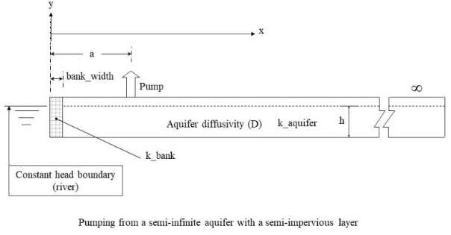

***Fig x3:*** *Uniform aquifer with horizontal base, diffusivity (D), saturated thickness (h). Fully penetrating river at x=0, a semi-pervious layer along the river bank, and a pump at distance x=a from the river.*

As *alpha* becomes smaller the “retardation” effect of the semi-pervious layer also reduces, which speeds up the stream depletion response. When *Alpha* is very small, the results converge back to the simpler Glover and Balmer solution case. (Fig x4)

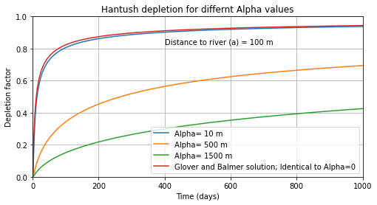

**Fig x4:** *Stream depletion (expressed as a proportion of pumping rate) for 4 different Alpha values, showing the solution reverts back to Glover & Balmer case for Alpha=0.*

Case 3: Depletion with a no flow boundary (Knight et al., 2005)

Knight et al. (2015) provide a solution which incorporates the effect of a no-flow boundary at a distance *x=c* from the river, where *c* is greater than or equal to the distance of the pump from the river (*a*) (Fig x5).

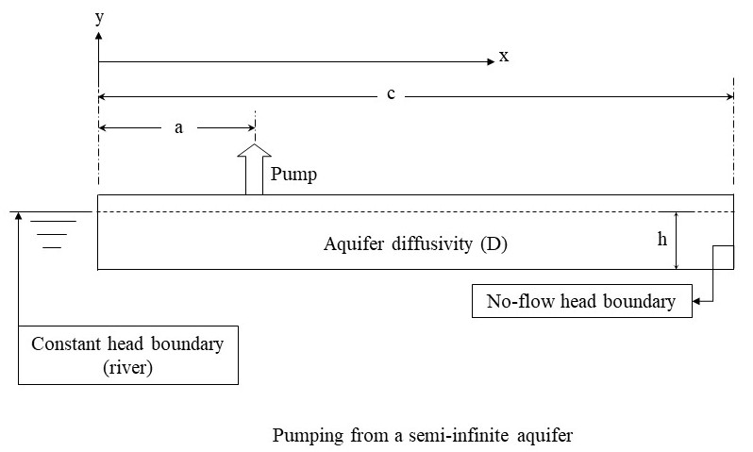

***Fig x5:*** *Uniform aquifer with horizontal base, diffusivity (D), saturated thickness (h). Fully penetrating river at x=0, a no-flow boundary at x=c (c>=a) (Knight et al. 2005).*

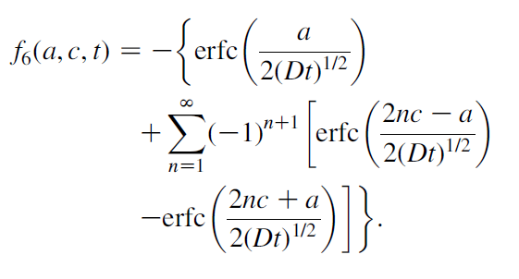

where *f6* is the stream depletion (as proportion of pumping rate).

[need to comment on how many n ( nmax=? ) are evaluated in the package]

Because the no-flow boundary is further away from the river than the pump, the longer-term stream depletion is affected more than the short-term. As the ratio of no-flow boundary distance to pump distance (*c/a*) becomes larger, the impact of the boundary reduces, and the solution converges back to the original Glover and Balmer solution for very large *c* (Fig x6).

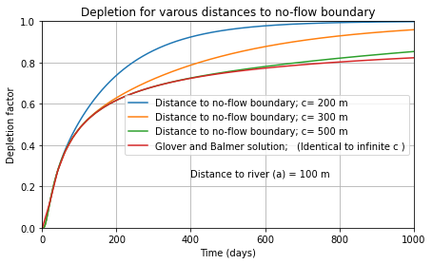

**Fig x6:** *Stream depletion (expressed as a proportion of pumping rate) for no-flow boundary at 4 distances, showing the solution reverts back to Glover & Balmer case as c tends to infinity.*

Case 4: Depletion for clogged partially penetrating stream (Hunt, 1999)

This case is similar to Case 2 with streambed clogging (Hantush, 1965), however it extends the complexity to account for situations where the stream only partially penetrates the aquifer (Hunt, 1999) (Fig x7).

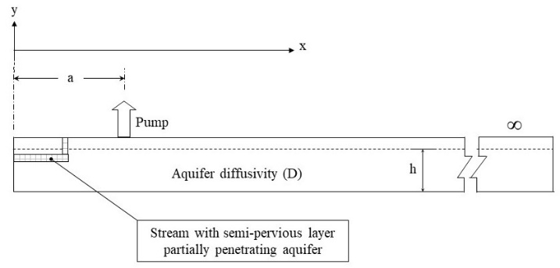

***Fig x7:*** *Uniform aquifer with horizontal base, diffusivity (D), saturated thickness (h). Partially penetrating river at x=0 with streambed clogging (Hunt, 1999).*

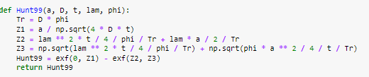

[sorry David I can’t work out what the equation is here]

Where ….

“Lambda is a constant of proportionality between the seepage flow rate per unit distance (in the y direction) through the streambed and the difference between the river and groundwater levels at x=0” (Hunt, 1999)

As Lambda increases, the effect of the clogged stream bed reduces. As lambda approaches infinity the solution converges to the Glover & Balmer solution (Fig x8).

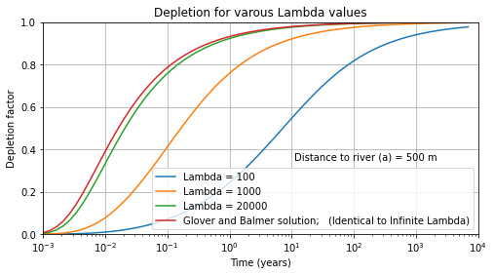

**Fig x8:** *Stream depletion (expressed as a proportion of pumping rate) for 4 different Lambda values, showing the solution reverts to Glover & Balmer case as Lambda approaches infinity.*

Case 5: Depletion in semi-confined aquifer (Hunt, 2003)

This case accounts for situations where the aquifer is semi-confined (Hunt, 2003) (Fig x9).

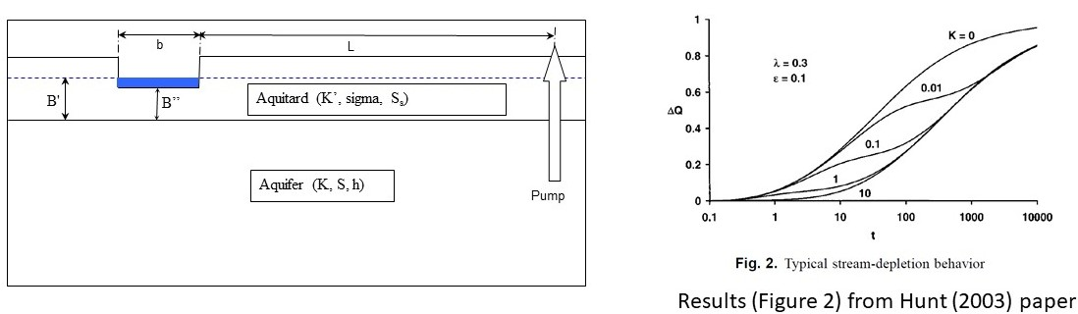

**Fig x9:** *Uniform aquifer with horizontal base, diffusivity (D), saturated thickness (h), overlain by a uniform aquitard with diffusivity (D’). Partially penetrating river at x=0 (Hunt, 2003).*

[sorry David – the equations here are too confusing for me]

Where:

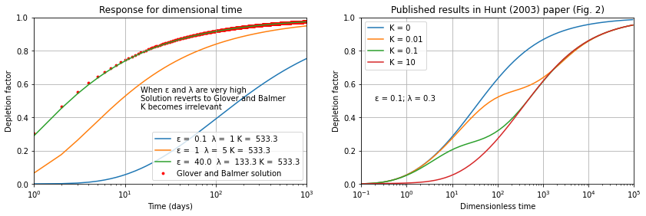

**Fig x10:** *Stream depletion (expressed as a proportion of pumping rate) for different Epsilon and Lambda values, showing the solution reverts to Glover & Balmer case as Epsilon and Lambda approach infinity.*

As expected, the solution reverts to the Glover & Balmer solution (Case 1) for very high 'epsilon' and 'lambda' values.

Case 6: Depletion in aquifer with two orthogonal rivers (Hantush, 1967)

This case provides the solution for when there are rivers are on two sides of the aquifer, approximating a bend or fork in a river (Hantush, 1967).

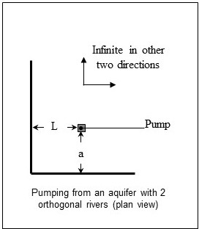

**Fig x11:** *Uniform semi-infinite aquifer with horizontal base, diffusivity (D), saturated thickness (h), with fully penetrating orthogonal rivers at distance (a and L) from the pumped well (Hantush, 1967)*

[sorry David – the equations here are too confusing for me]

Where:

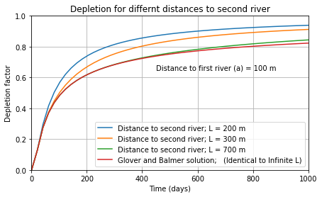

**Fig x12:** *Stream depletion (expressed as a proportion of pumping rate) as the distance to the second river (L) is increase, showing the solution reverts to Glover & Balmer case as L becomes much larger than a.*

This solution is also shown to revert to the Glover & Balmer solution for very high distance to second river (L).

Case 7: Depletion in aquifer with three orthogonal rivers (by John Knight; reported in Rassam et al (2004)

This case extends the case of 2 orthogonal rivers (Hantush, 1967) by including a third river. This approximates the situation of well inside a tight bend or oxbow (Fig x13).

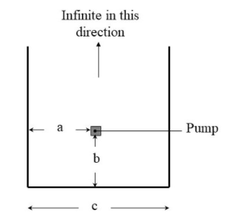

**Fig x13:** *Uniform semi-infinite aquifer with horizontal base, diffusivity (D), saturated thickness (h), with three fully penetrating orthogonal rivers at distance (a, b, (c-1a)) from the pumped well (Knight, via Rassam et al. 2004)*

[sorry David – the equations here are too confusing for me]

Where:

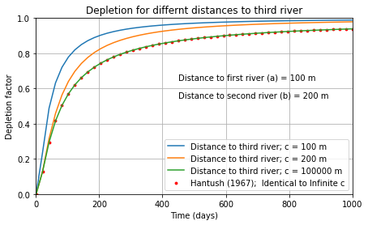

**Fig x14:** *Stream depletion (expressed as a proportion of pumping rate) as the distance to the third river (c-a) increases, showing the solution reverts to Case 6 (Hantush, 1967) as c becomes much larger than a.*

Case 8: Flux distribution along the river (by John Knight, reported in Rassam et al. (2004)

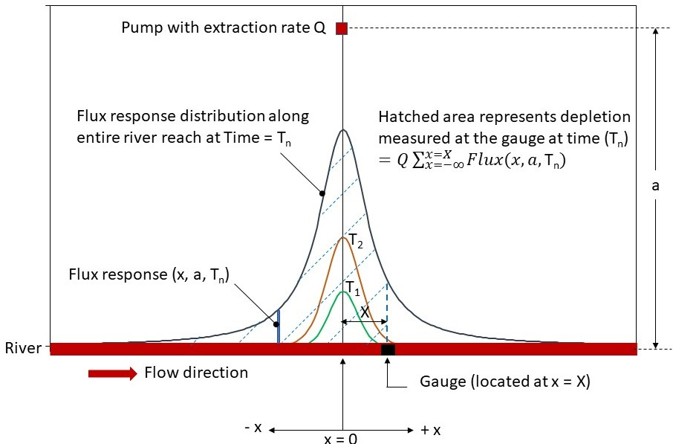

**Fig x15:**

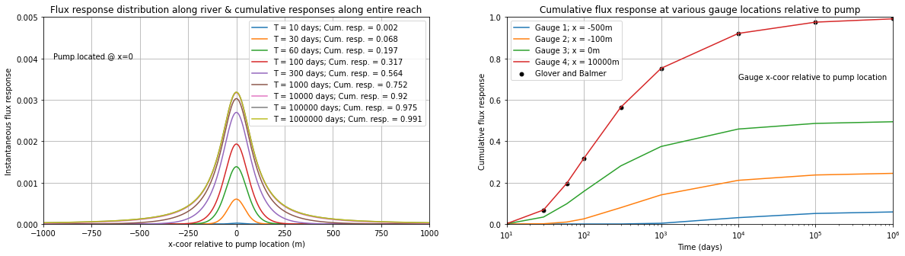

**Fig x16:**

Other examples

Calculate probability to exceed threshold depletion as a function of time at different distances to river considering log-normally distributed aquifer dispersivities

Calculate individual and cumulative depletion for multiple pumps using superposition; different distances to river and aquifer diffusivity, different pumping rates and starting times (defined by a delay period after the first)

Pump1 starts immediately, Pump2 starts after 200 days, Pump3 starts after 500 days

Calculate depletion for scheduled pumping (single pump with time-variable rates) using superposition

Calculate cumulative depletion in a development due to multiple pumps where each pump is associated with: (1) different location, (2) different pumping rate schedule, (3) different aquifer diffusivity, (4) different activation time

**Usage**

**Conclusions**

**Software Availability**

**Acknowledgements**

**References**

Glover, R.E., and G.G. Balmer. 1954. River depletion resulting from pumping a well near a river. *Transactions, American Geophysical Union* 35(3): 468–470.

Hantush, M.S., 1965. Wells near streams with semi-pervious beds. *Journal of Geophysical Research* 70 (12), 2829-2838. <https://doi.org/10.1029/JZ070i012p02829>

Hantush, M.S., 1967. Depletion of flow in right-angle stream bends by steady wells. Water Resources Research 3(1):235-240. https://doi.org/10.1029/WR003i001p00235

Hunt, B., 1999. Unsteady stream depletion from ground water pumping. *Ground Water* 37(1): 98–102.

Hunt, B., 2003. Unsteady stream depletion when pumping from semiconfined aquifer. *Journal of Hydrologic Engineering* 8(1), 12-19.

Knight, J.H., M. Gilfedder, and G.R. Walker. 2005. Impacts of irrigation and dryland development on groundwater discharge to rivers - A unit response approach to cumulative impacts analysis. *Journal of Hydrology* 303(1–4): 79–91.

Theis, C.V., 1940. “The source of water derived from wells: Essential factors controlling the response of an aquifer to development,” Civil Eng., Vol. 10: pp. 277–280

**RANDOM RELATED LITERATURE WHICH COULD BE USEFUL**

Barlow, P.M., Leake, S.A. and Fienen, M.N. (2018), Capture Versus Capture Zones: Clarifying Terminology Related to Sources of Water to Wells. Groundwater, 56: 694-704. <https://doi.org/10.1111/gwat.12661>

Bredehoeft, J., and E. Kendy. 2008. Strategies for offsetting seasonal impacts of pumping on a nearby stream. *Ground Water* 46(1): 23–29.

Hantush, M.M., Harada, M., Mariño, M.A., 2002. Hydraulics of streamflow routing with bank storage. *Journal of Hydrologic Engineering* 7 (1), 76-89.

Knight, J.H., and D.W. Rassam. 2007. Groundwater head responses due to random stream-stage fluctuations using basis splines. *Water Resources Research*, W06501. doi:10.1029/2006WR005155.

Kraijenhoff van de Leur, D.A. 1958. A study of non-steady groundwater flow with special reference to a reservoir-coefficient. *De Ingenieur* 70(19): 87–94.

Sophocleous, M. 2012. On understanding and predicting groundwater response time. *Ground Water* 50(4): 528–540.

Sophocleous, M., A. Koussis, J.L. Martin, and S.P. Perkins. 1995. Evaluation of simplified stream-aquifer depletion models for water rights administration. *Ground Water* 33(4): 579–588.

Sophocleous, M., 2010. Review: groundwater management practices, challenges, and innovations in the High Plains aquifer, USA - lessons and recommended actions. *Hydrogeology Journal* 18(3):559-575.

Theis, C.V. 1941. The effect of a well on the flow of a nearby stream. *American Geophysical Union Transactions* 22(3): 734–738.

Walton, W. 2011. Aquifer system response time and groundwater supply management. *Ground Water* 49(2): 126–127.

Welsh W.D., J. Vaze, D. Dutta, D. Rassam, J.M. Rahman, I.D. Jolly, P. Wallbrink, G.M. Podger, M. Bethune, M.J. Hardy, J. Teng, and J. Lerat. 2013. An integrated modelling framework for regulated river systems. *Environmental Modelling & Software* 39: 81-102.

Zlotnik, V. A., and H. Huang. 1999. Effect of shallow penetration and streamed sediments on aquifer response to stream stage fluctuations (analytical model). *Ground Water* 37(4): 599–605.

**Supplementary Material**

For each METHOD:

Description

Example

Solution

Figure

e.g. ERFC

What it does

References for development (Theis, GB, Knight, Rassam....etc.)